**Air Travel Safety**

# Introduction

Flying has been a preferred way of travel for a long time. Air traffic has increased over the decade and it is expected grow even more. It is an exciting experience for a first-time flyer. I remember my first experience and how excited I was. Flying is faster, cheaper and only way of travel in some cases.

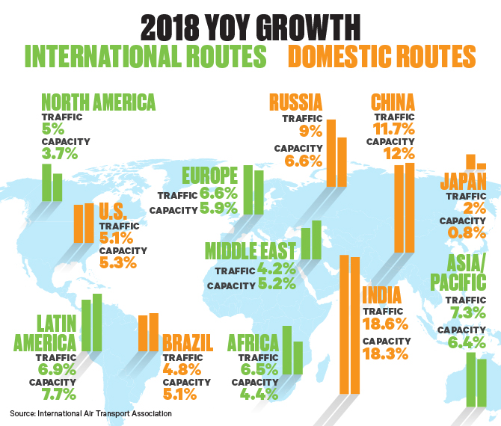

Today we are going to discuss if flying is also the safer way of travel. There have been a few incidents that have caused a lot of human life loss and people have raised question if air travel is safe anymore. I believe, there is an element of risk involved with flying but the same applies to any other modes including road, rail and ocean. Latest media reports suggest that air travel is not safe at all but instead of basing this judgement on one of instances, one should look at the data over the period of time and analyze the trends and severity of these modes of transportation and compare them side by side.

# Air Traffic

Air traffic over the years has only increased. As the population grew, as expected need for travel and in turn air travel also has increased. There have been significant improvements in technologies around aircraft and communication equipment which has helped increase the safety measures onboard and beyond. Diagram below shows how air traffic has increased over the years

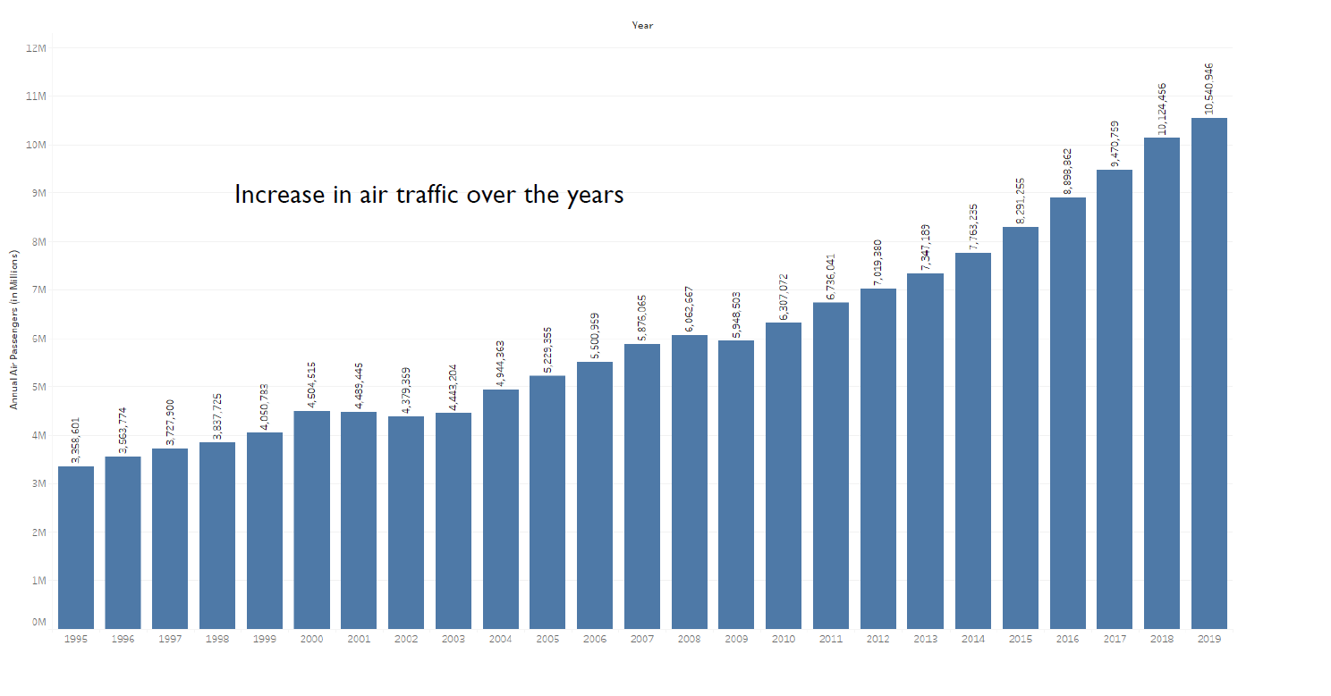

As number of passengers travelling by air has increased, we may see some increase in air accidents and fatalities too. We analyzed the fatalities data by air accidents, and it seems there is a declining trend. Below diagram shows number of fatalities over the years. Even though there are many spikes in the graph, but overall trend is showing the decline.

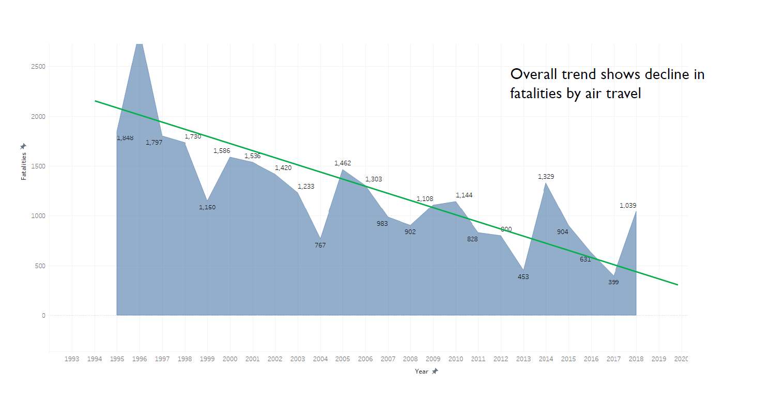

# Road Travel

It is true that majority of population uses road to travel from point A to point B. It is not an optional mode, even if you are flying, you must use road to get to the airport. There is a lot more traffic on the road than any other mode. Given that a lot more people use the road and resources in the road traffic systems are limited, it is expected to have more accidents in road travel. Technologies around road safety also has improved over the years and vehicles now are equipped with many advance features like Adaptive cruise control, lane departure alert and many others. Despite these advance features National highway traffic data around number of crashes and number of fatalities show that there is no decline in the crashes or fatalities.

Diagram below shows the number of crashes from 1993 to 2019 and it has been somewhere between 500k to 700k but there is no declining trend rather it looks much flatter.

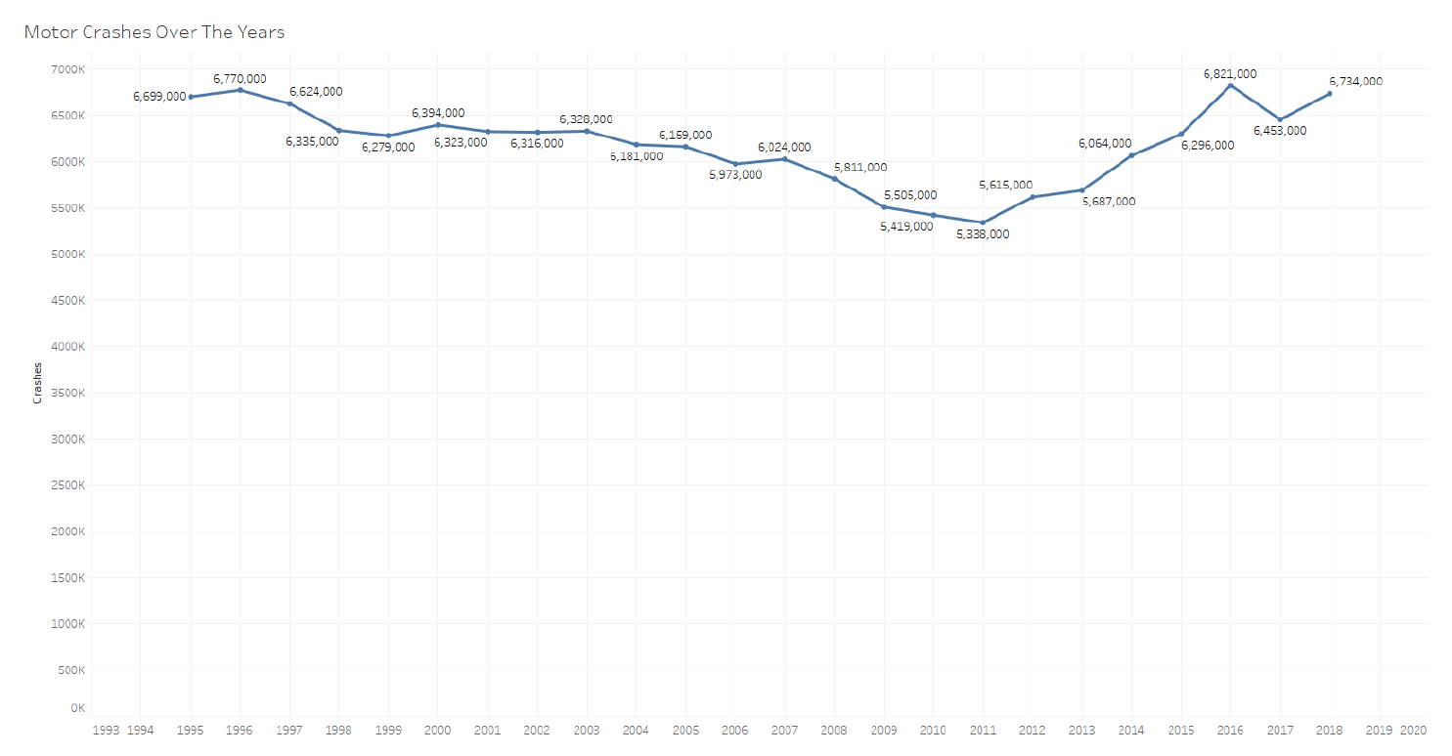

Similar to diagram above below is the graph between number of fatalities between 1993 and 2019 and it also shows that number of fatalities has been flatter with a small dip between 2007 and 2016 but overall the number of fatalities is very high in road travel as compared to air travel.

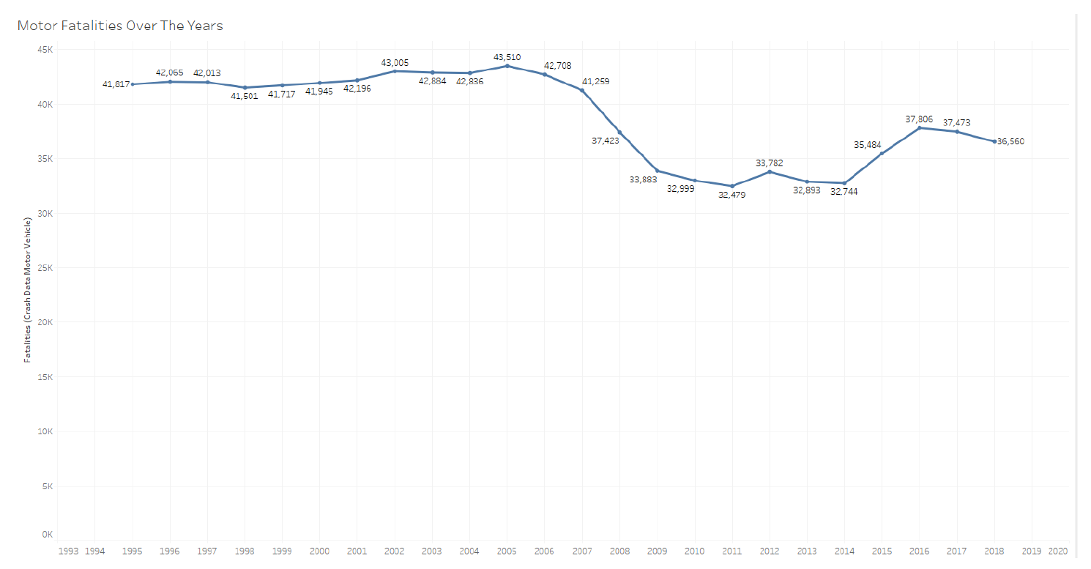

# Conclusion

Based on the data and comparison above, air travel has clearly less accidents and a smaller number of fatalities. Aviation industry is investing a lot of time and resources in making the air travel more and more safe and enjoyable for there customers. Advancements in technology and air traffic control equipment is going to get even more safer in the future. With the new technologies around video conferencing and Internet speed (5G), some of travel need may get impacted but it is expected that air traffic is going to increase in the future.

# References

[1] <https://www.businesstravelnews.com/Global/Global-Air-Traffic-Growth-Outpaced-Capacity-Growth-in-2018>

[2] [data/airline-safety at master · fivethirtyeight/data · GitHub](https://github.com/fivethirtyeight/data/tree/master/airline-safety)